Cassandra

Architecture in brief
Cassandra is designed to handle big data workloads across multiple nodes with no single point of failure. Its architecture is based on the understanding that system and hardware failures can and do occur. Cassandra addresses the problem of failures by employing a peer-to-peer distributed system across homogeneous nodes where data is distributed among all nodes in the cluster. Each node frequently exchanges state information about itself and other nodes across the cluster using peer-to-peer gossip communication protocol. A sequentially written commit log on each node captures write activity to ensure data durability. Data is then indexed and written to an in-memory structure, called a memtable, which resembles a write-back cache. Each time the memory structure is full, the data is written to disk in an SSTables data file. All writes are automatically partitioned and replicated throughout the cluster. Cassandra periodically consolidates SSTables using a process called compaction, discarding obsolete data marked for deletion with a tombstone. To ensure all data across the cluster stays consistent, various repair mechanisms are employed.
Cassandra is a partitioned row store database, where rows are organized into tables with a required primary key. Cassandra's architecture allows any authorized user to connect to any node in any datacenter and access data using the CQL language. For ease of use, CQL uses a similar syntax to SQL and works with table data. Developers can access CQL through cqlsh, DevCenter, and via drivers for application languages. Typically, a cluster has one keyspace per application composed of many different tables.
Client read or write requests can be sent to any node in the cluster. When a client connects to a node with a request, that node serves as the coordinator for that particular client operation. The coordinator acts as a proxy between the client application and the nodes that own the data being requested. The coordinator determines which nodes in the ring should get the request based on how the cluster is configured.

- Node
Where you store your data. It is the basic infrastructure component of Cassandra.
- datacenter
A collection of related nodes. A datacenter can be a physical datacenter or virtual datacenter. Different workloads should use separate datacenters, either physical or virtual. Replication is set by datacenter. Using separate datacenters prevents Cassandra transactions from being impacted by other workloads and keeps requests close to each other for lower latency. Depending on the replication factor, data can be written to multiple datacenters. datacenters must never span physical locations.
- Cluster
A cluster contains one or more datacenters. It can span physical locations.
- Commit log
All data is written first to the commit log for durability. After all its data has been flushed to SSTables, it can be archived, deleted, or recycled.
- SSTable
A sorted string table (SSTable) is an immutable data file to which Cassandra writes memtables periodically. SSTables are append only and stored on disk sequentially and maintained for each Cassandra table.
- CQL Table
A collection of ordered columns fetched by table row. A table consists of columns and has a primary key.

Key components for configuring Cassandra
- Gossip
A peer-to-peer communication protocol to discover and share location and state information about the other nodes in a Cassandra cluster. Gossip information is also persisted locally by each node to use immediately when a node restarts.
- Partitioner
A partitioner determines which node will receive the first replica of a piece of data, and how to distribute other replicas across other nodes in the cluster. Each row of data is uniquely identified by a primary key, which may be the same as its partition key, but which may also include other clustering columns. A partitioner is a hash function that derives a token from the primary key of a row. The partitioner uses the token value to determine which nodes in the cluster receive the replicas of that row. The Murmur3Partitioner is the default partitioning strategy for new Cassandra clusters and the right choice for new clusters in almost all cases.
You must set the partitioner and assign the node a num_tokens value for each node. The number of tokens you assign depends on the hardware capabilities of the system. If not using virtual nodes (vnodes), use the initial_token setting instead.
- Replication factor
The total number of replicas across the cluster. A replication factor of 1 means that there is only one copy of each row on one node. A replication factor of 2 means two copies of each row, where each copy is on a different node. All replicas are equally important; there is no primary or master replica. You define the replication factor for each datacenter. Generally you should set the replication strategy greater than one, but no more than the number of nodes in the cluster.
- Replica placement strategy
Cassandra stores copies (replicas) of data on multiple nodes to ensure reliability and fault tolerance. A replication strategy determines which nodes to place replicas on. The first replica of data is simply the first copy; it is not unique in any sense. The NetworkTopologyStrategy is highly recommended for most deployments because it is much easier to expand to multiple datacenters when required by future expansion.
When creating a keyspace, you must define the replica placement strategy and the number of replicas you want.
- Snitch
A snitch defines groups of machines into datacenters and racks (the topology) that the replication strategy uses to place replicas.
You must configure a snitch when you create a cluster. All snitches use a dynamic snitch layer, which monitors performance and chooses the best replica for reading. It is enabled by default and recommended for use in most deployments. Configure dynamic snitch thresholds for each node in the cassandra.yaml configuration file.
The default SimpleSnitch does not recognize datacenter or rack information. Use it for single-datacenter deployments or single-zone in public clouds. The GossipingPropertyFileSnitch is recommended for production. It defines a node's datacenter and rack and uses gossip for propagating this information to other nodes.
- The cassandra.yaml configuration file
The main configuration file for setting the initialization properties for a cluster, caching parameters for tables, properties for tuning and resource utilization, timeout settings, client connections, backups, and security.
By default, a node is configured to store the data it manages in a directory set in the cassandra.yaml file.
In a production cluster deployment, you can change the commitlog-directory to a different disk drive from the data_file_directories.
- System keyspace table properties
You set storage configuration attributes on a per-keyspace or per-table basis programmatically or using a client application, such as CQL.

Consistent hashing
Consistent hashing allows distribution of data across a cluster to minimize reorganization when nodes are added or removed. Consistent hashing partitions data based on the partition key. (For an explanation of partition keys and primary keys, see the Data modeling example in CQL for Cassandra 2.2 and later.)
For example, if you have the following data:

name | age | car | gender
jim | 36 | camaro | M
carol | 37 | bmw | F
johnny | 12 |  | M
suzy | 10 |  | F
Cassandra assigns a hash value to each partition key:

Partition key | Murmur3 hash value
jim | -2245462676723223822
carol | 7723358927203680754
johnny | -6723372854036780875
suzy | 1168604627387940318
Each node in the cluster is responsible for a range of data based on the hash value.
Hash values in a four node cluster
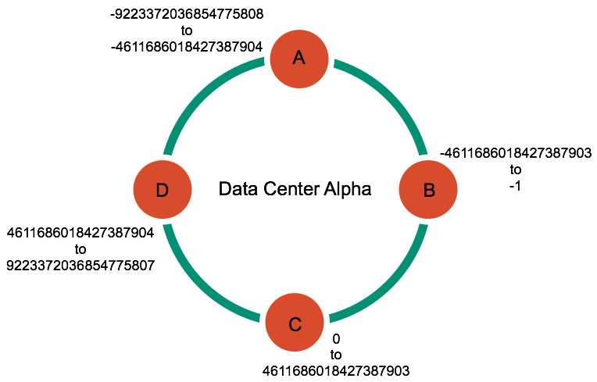
Cassandra places the data on each node according to the value of the partition key and the range that the node is responsible for. For example, in a four node cluster, the data in this example is distributed as follows:

Node | Start range | End range | Partition key | Hash value
A | -9223372036854775808 | -4611686018427387904 | johnny | -6723372854036780875
B | -4611686018427387903 | -1 | jim | -2245462676723223822
C | 0 | 4611686018427387903 | suzy | 1168604627387940318
D | 4611686018427387904 | 9223372036854775807 | carol | 7723358927203680754

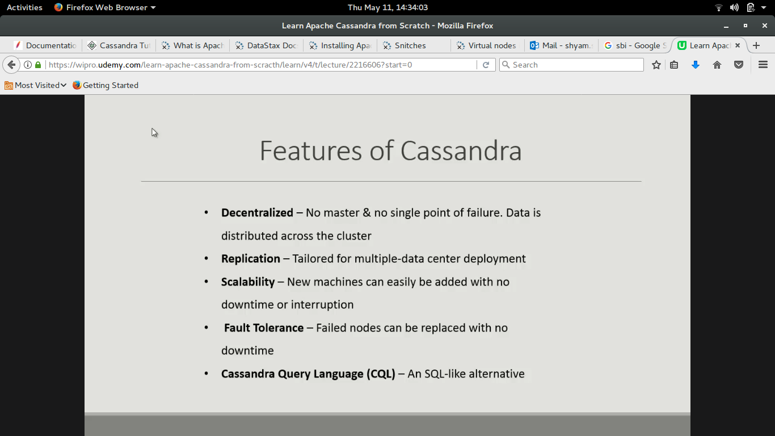

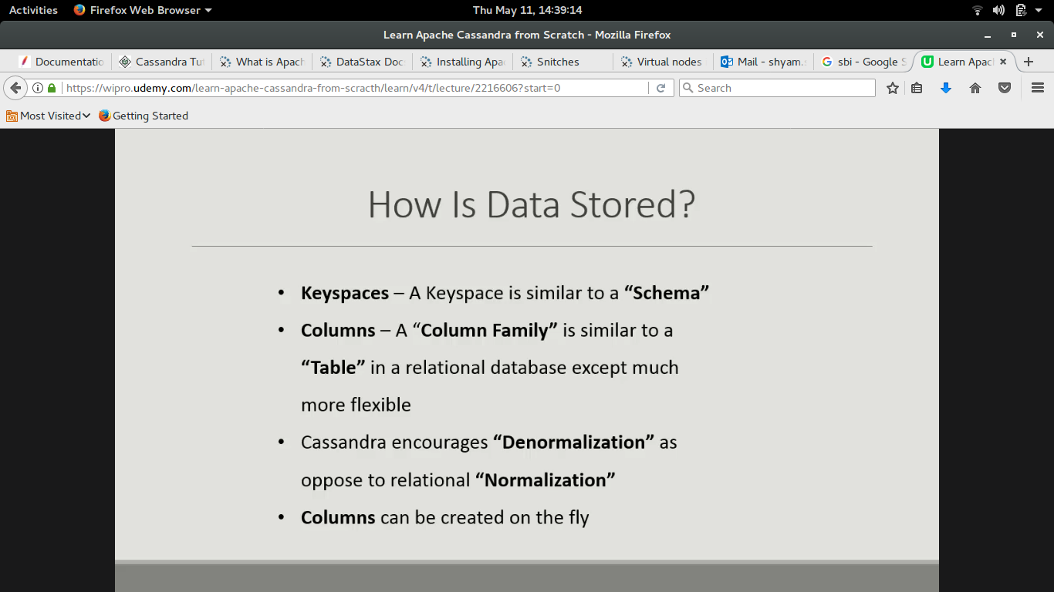
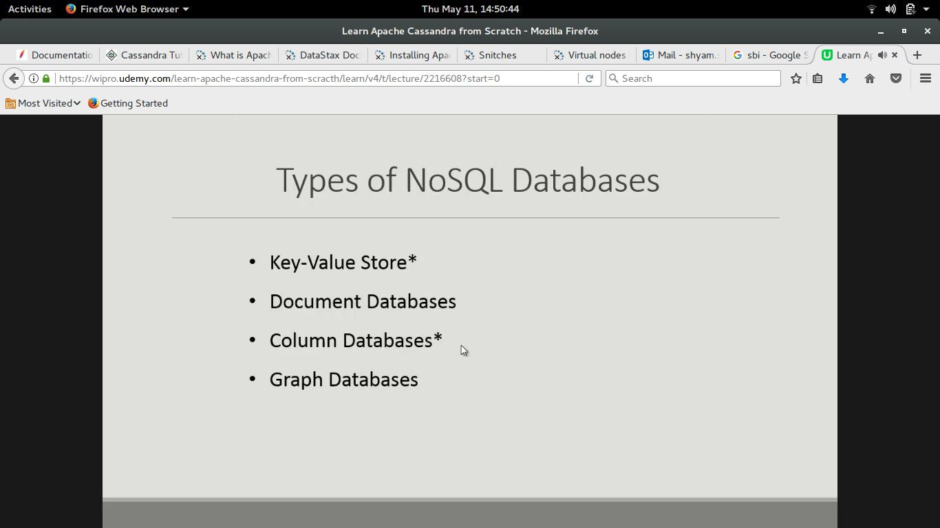
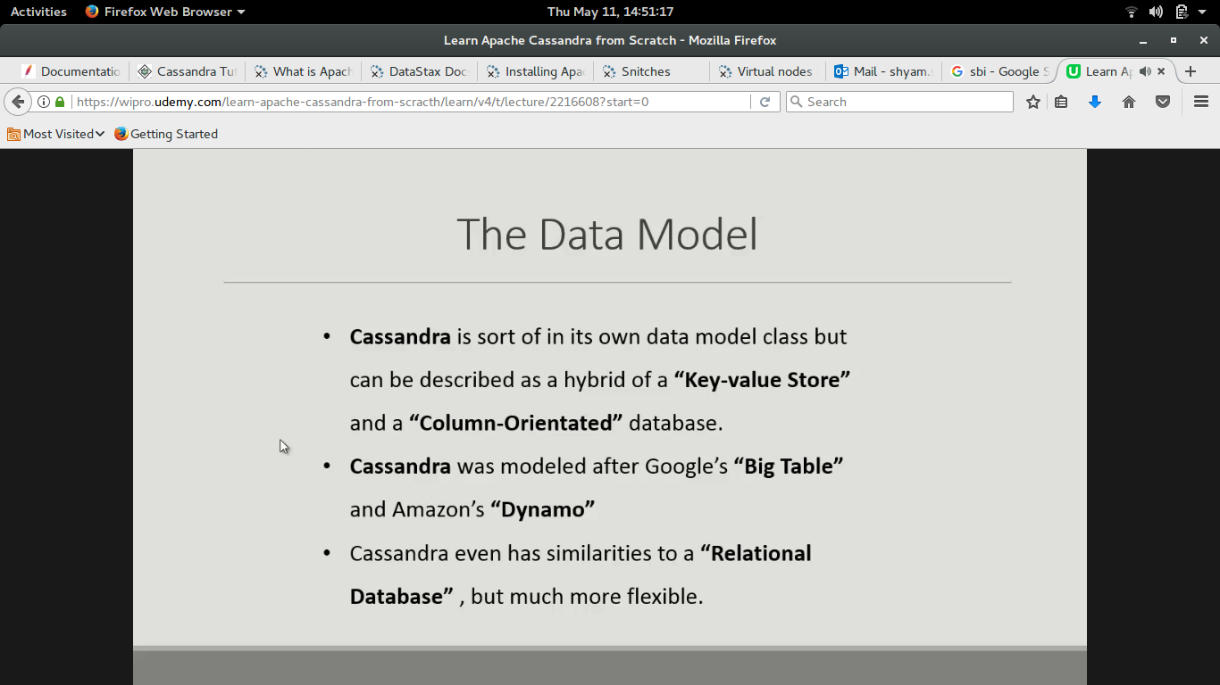
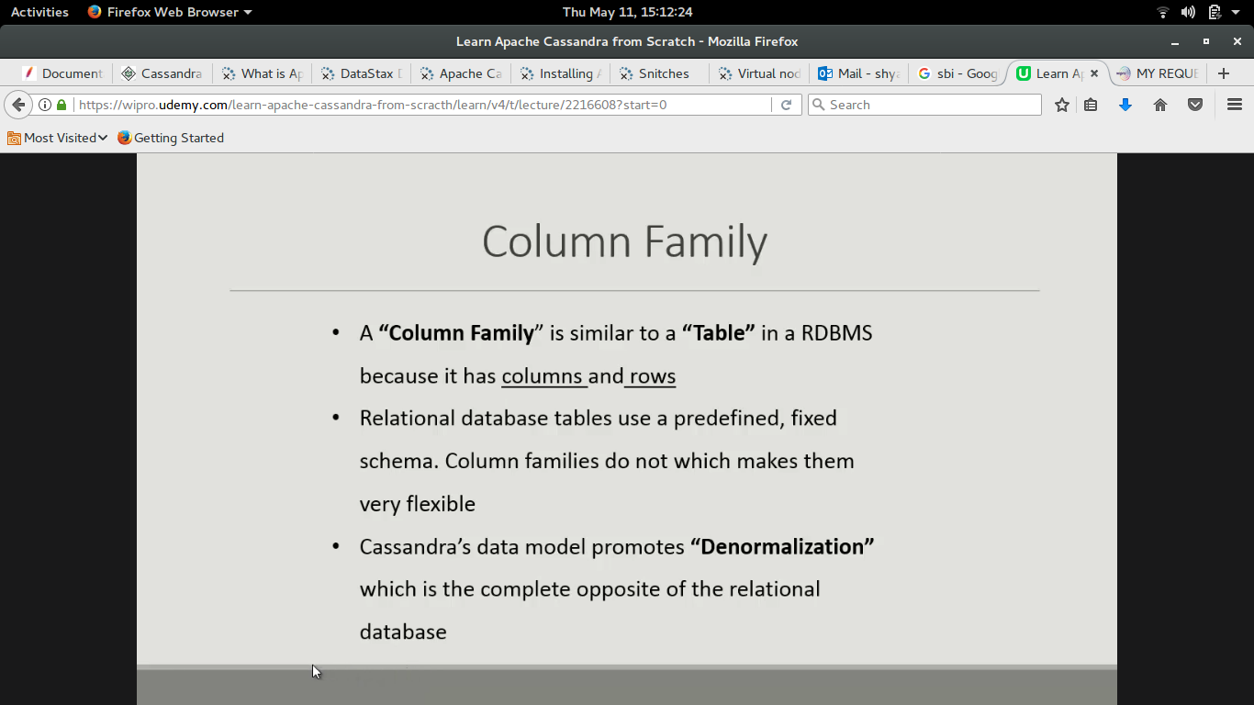

Cassandra has dynamic column, which means there is no prior order of columns, each row can has any order and no. Of column.

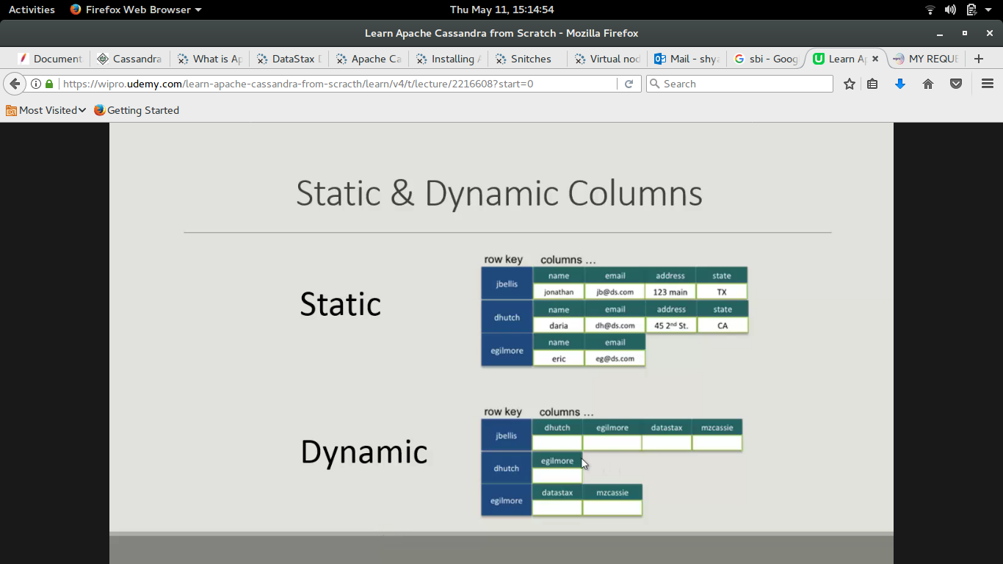
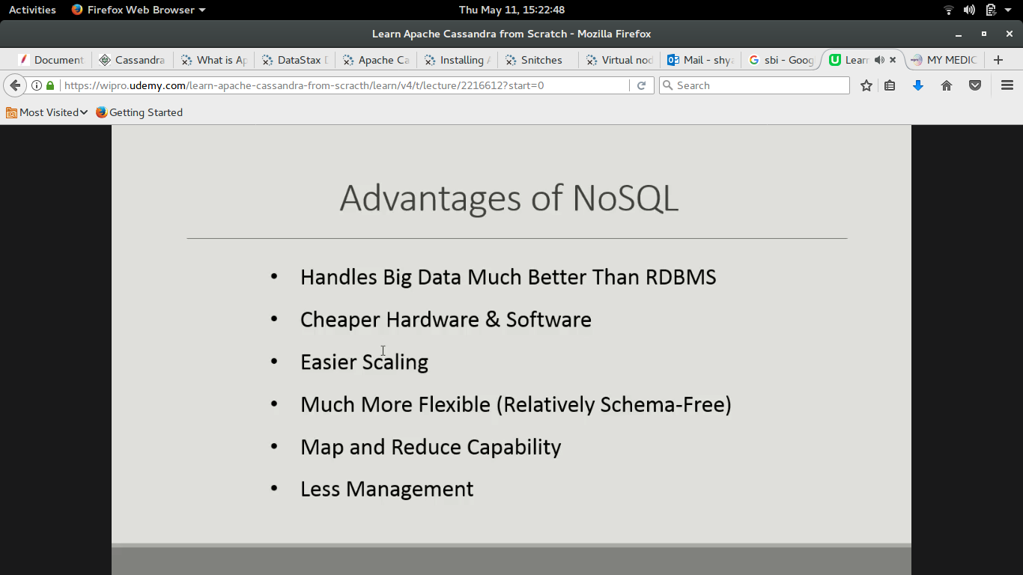
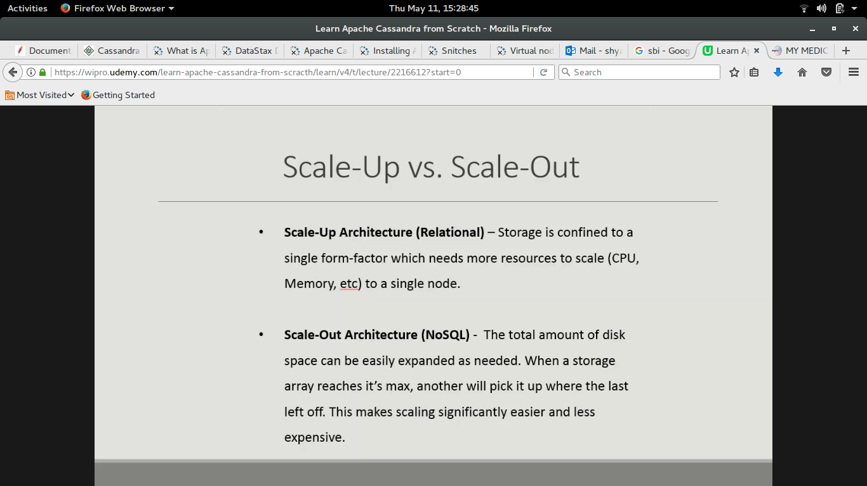

Write Process:

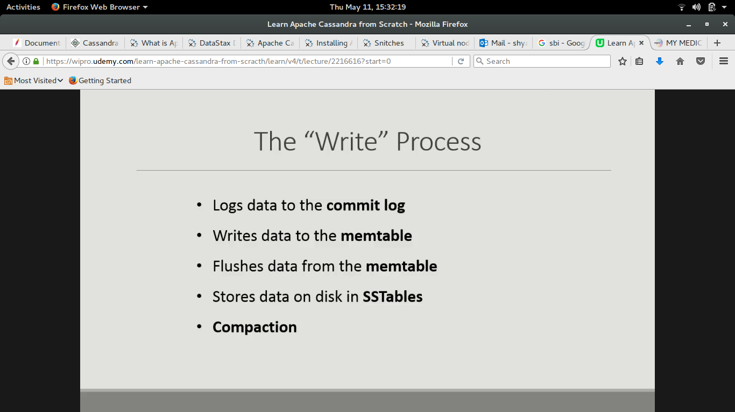

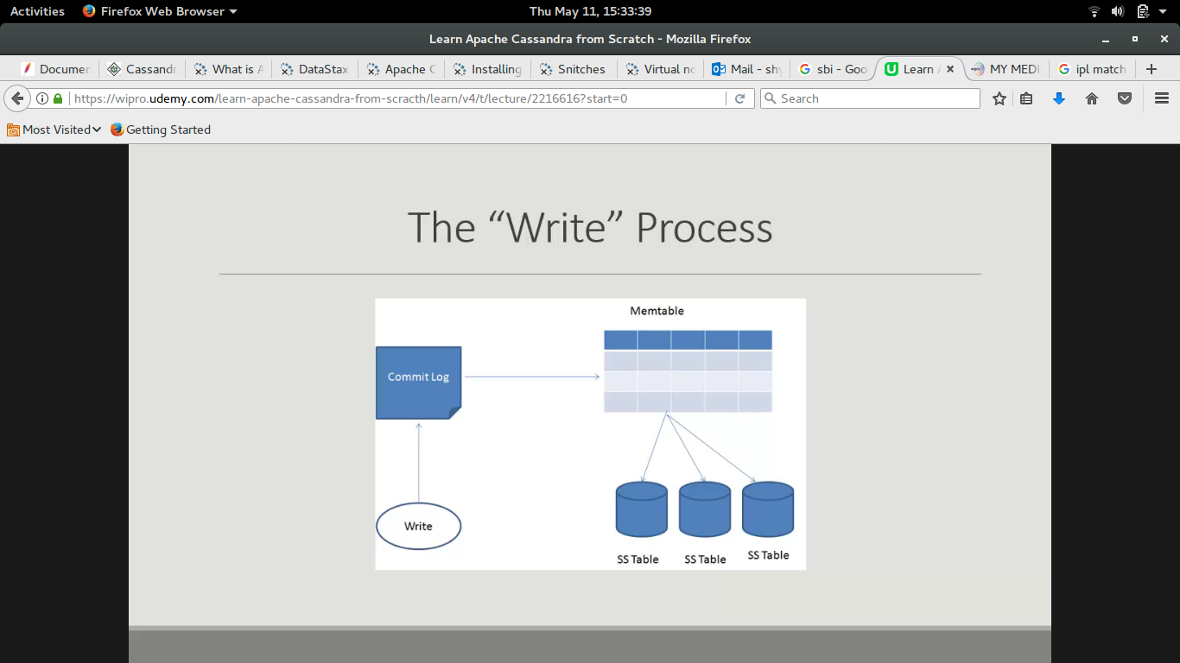

The Commit Log :

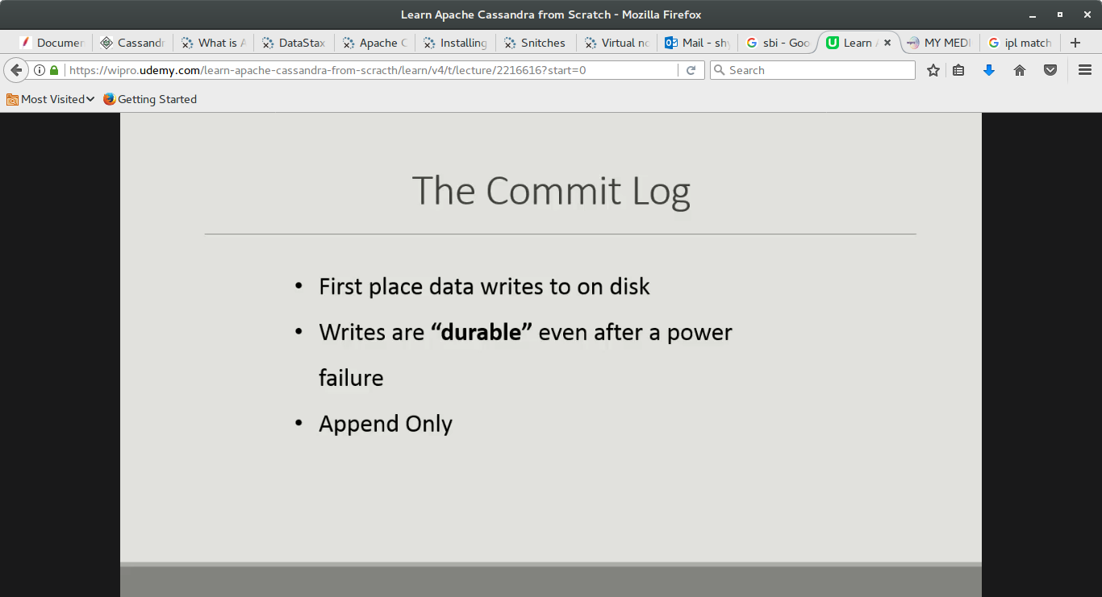

Compaction :

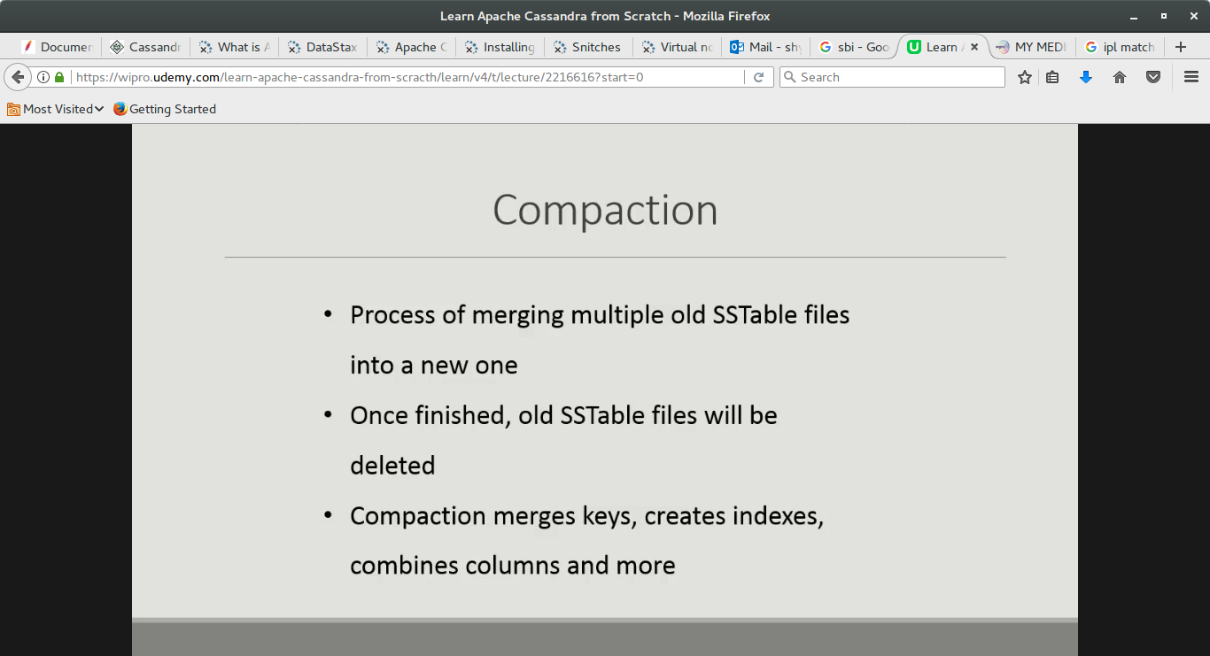

Writting CQL:

Using Keyspace

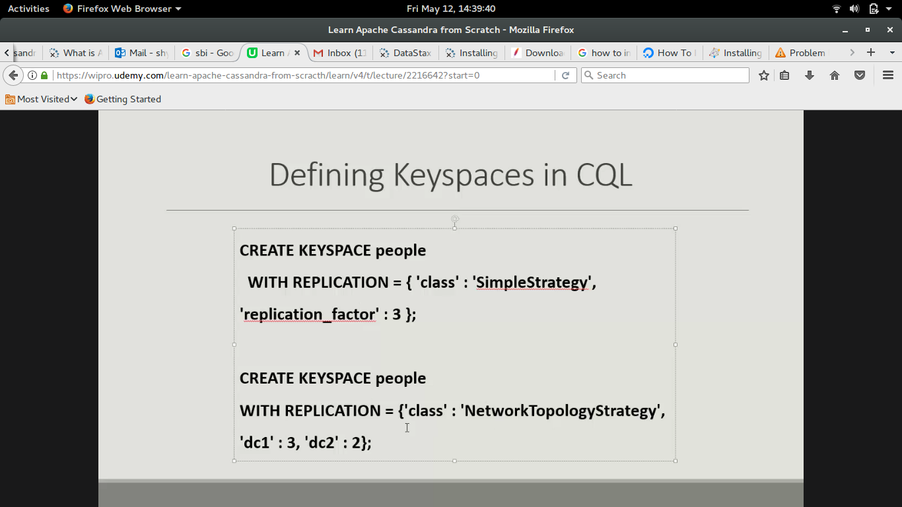

dc1 and dc2 are datacenter and 3 and 2 are no. Of replica with corresponding datacenter.

Compound key :

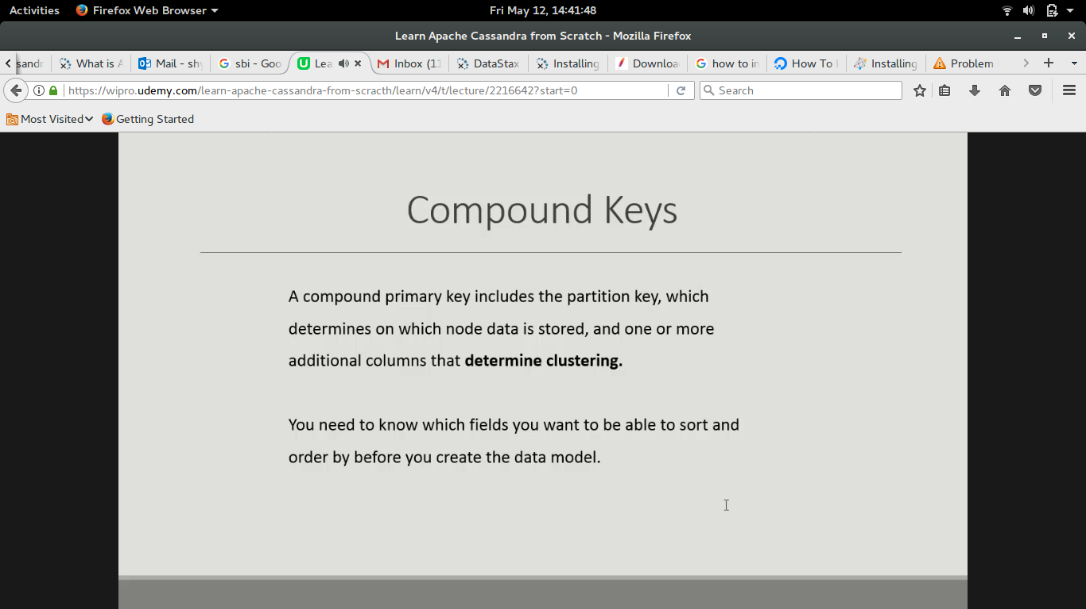
Create table :

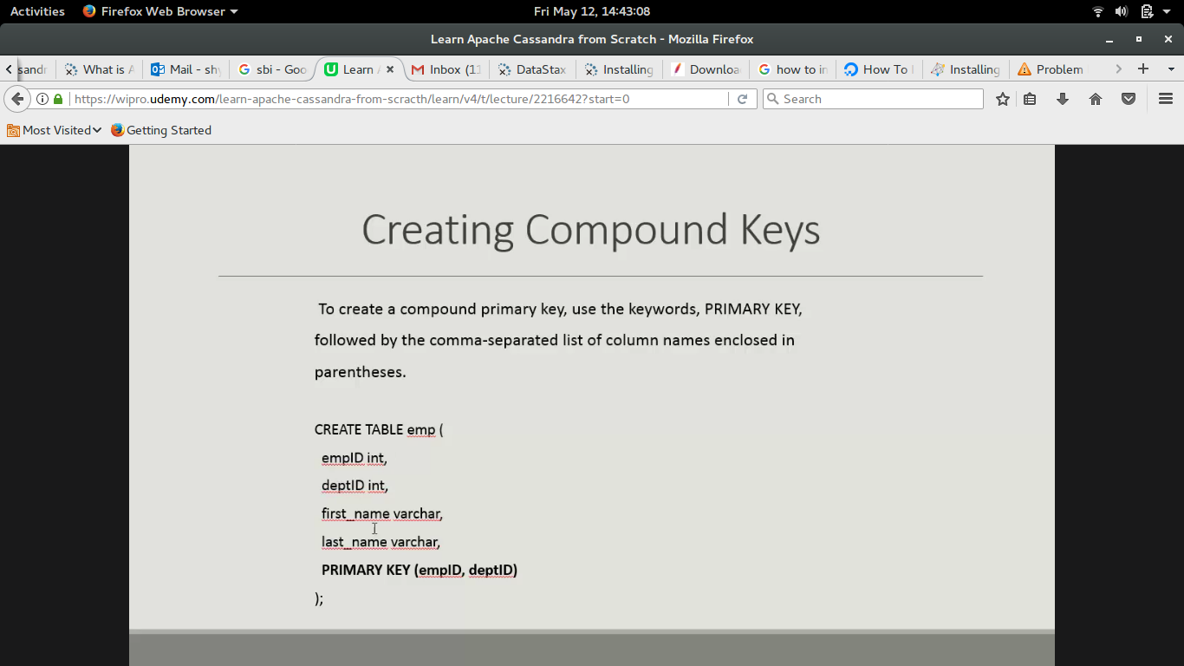
empId is partion key.
Primary key field is for compund key and include all the fields where sorting or ordering is required.

Selecting Data:

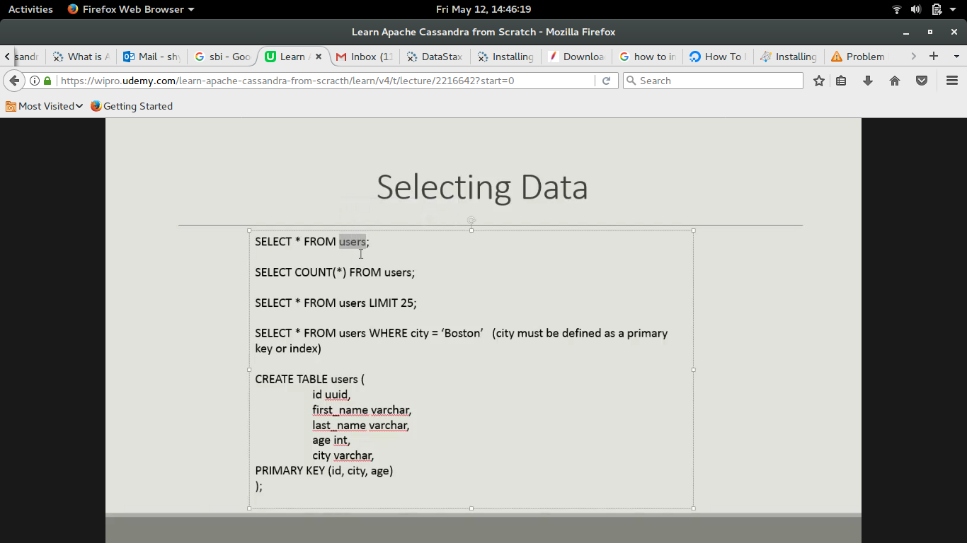

Insert data :

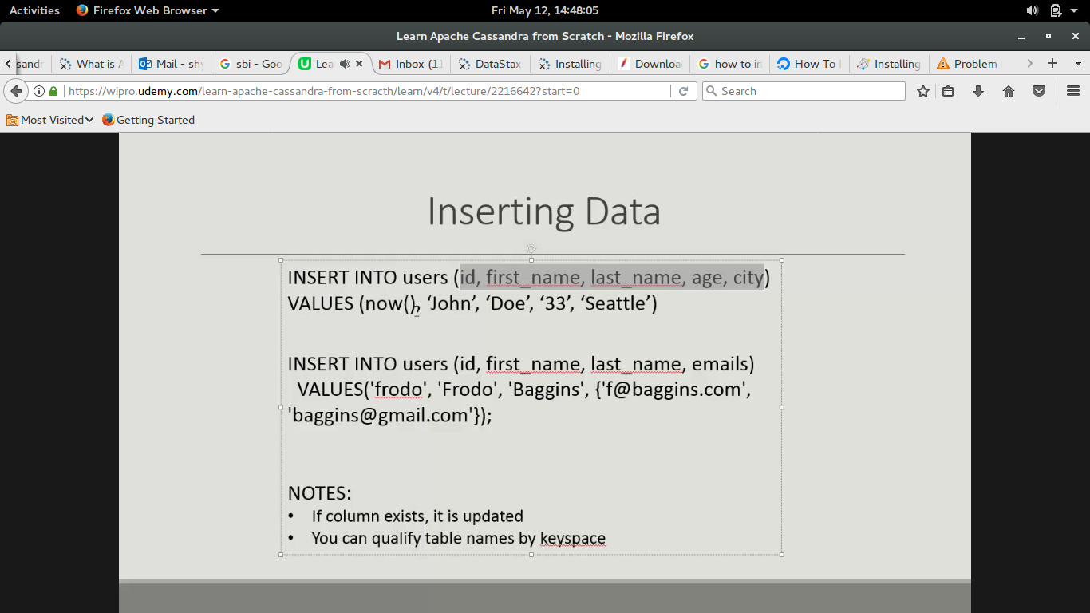

Update Table :

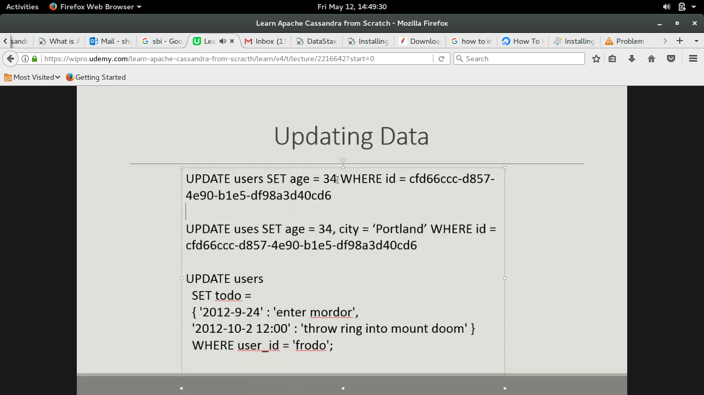

Delete Data :

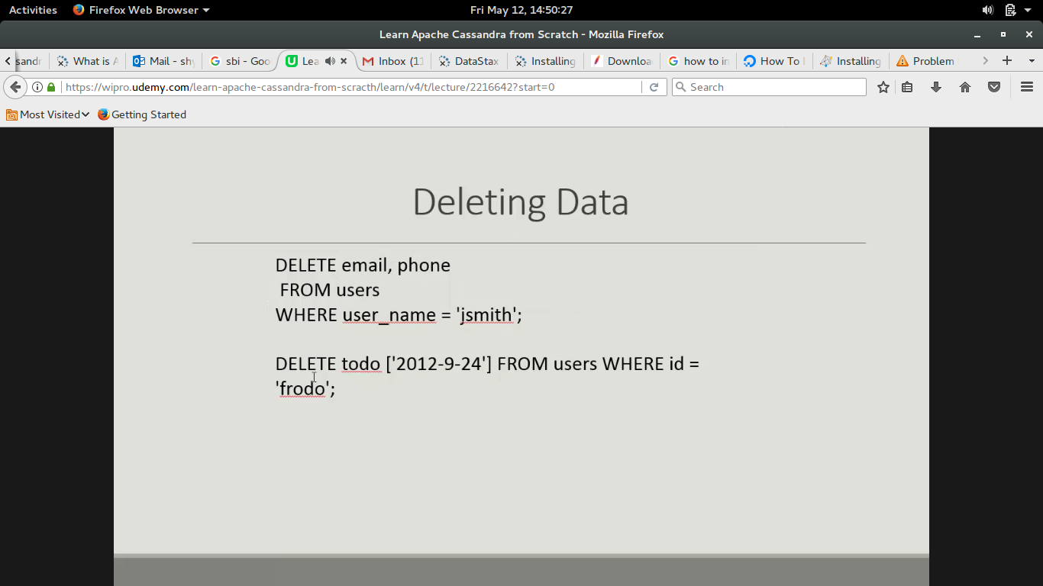

Alter Table :

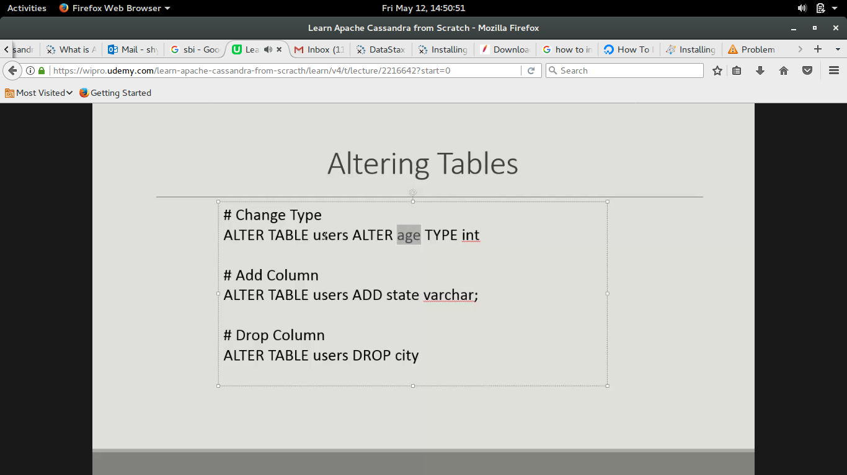

Need to create table based on what result we want to show

Batch query :

